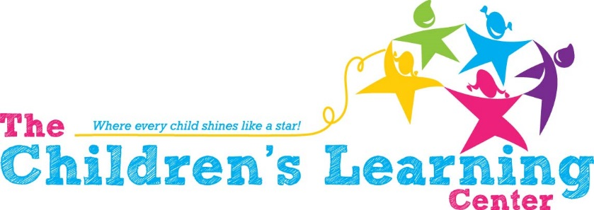

Bus Driver Opening

The Children’s Learning Center in Madras, Oregon is looking for a dynamic, energetic, patient, fun and organized individual to work with children and staff in our Oregon Prekindergarten program. The person will be responsible for transporting children 3 times a day to and from the center. There may be times when transportation for field trips is also required.

Physical and mental requirements may include sitting in child size chairs, kneeling, and bending to child’s level. Staff member may also lift or move heavy and/or bulky objects or children weighing up to 50 pounds. Staff member may have to respond to emergency scenarios and use their senses to maintain safety of the environment and children.

The position is a 9-month position approximately 32 hours a week. (May change based on position need) Some benefits are available which include sick and vacation time.

The position requires a valid CDL and driving record free of violations within the last three years. Must also have the school bus driver endorsement and pass requirements required for continuous licensing. Preferred credentials at hiring but willing to help train the right person. Enrollment in the Criminal Background Registry required prior to employment. Pay is determined by experience.

Interested parties may stop by the center, mail, fax or visit our website for an application. Please include your resume and letter of interest with your application. Open until filled.

Contact information
Alba Canales, Office Manager
Phone: 541-475-3628 Fax: 541-475-2583
www.madrastclc.org
email: career@madrastclc.org

