The children’s learning center
COVID-19 Health & Safety Plan
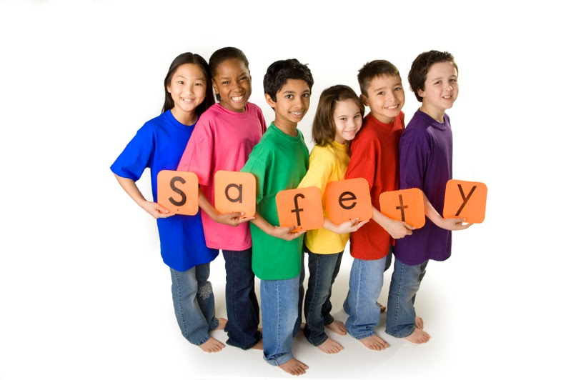
Plan 2.0
Updated January 2021

Contents
Drop –Off and pick-up 2
Daily health checks 2
Record keeping 4
Family engagement/Educational component 4
group size and stable groups 5
personal protective equipment for children and adults 6
Daily activities 7
hand washing and general hygiene 7
food and nutrition 8
cleaning and building maintenance practices 8
preparation for confirmed case and possible closure 9
Transportation 9
Professional development 9
Appendix 10
Appendix A 10
Appendix B 11
Appendix B 11
appendix C 15
Appendix D 16

Introduction
The Children’s Learning Center has developed a COVID-19 Health and Safety Plan based on information supplied by the Office of Childcare (OCC), Early Learning Division (ELD), Oregon Health Authority (OHA), Center for Disease Control and OSHA. This plan is to show our commitment to the staff and families that are served by our program. This plan takes the rules set forth by the governing authorities while adopting changes to meet the unique needs of our facility.
This plan will be shared a variety of ways which includes:
- Paper copy provided to staff along with a training regarding protocols.
- Paper copy provided to all families (if possible). Parents will also sign a COVID acknowledgement form located in Child Plus.
- Posted on our website: madrastclc.org
- Posted announcement in Class Dojo of where to locate our protocol.
- Printed copies available at the front entrance.
- Translated in Spanish.
Oversite of the plan is administered by Teresa Martin, Executive Director. In addition to Teresa, all leadership team members are expected to help enforce and understand guidance set in this document. Staff and parents can direct any questions to Teresa or the leadership team. The team will also utilize the Jefferson County Health Department in determining best steps when a case does affect the center. All staff are expected to follow protocols and regulations. Staff can remind each other of expectations or report non-compliance to leadership.
Rules are subject to change based on any new guidance set forth by governing authorities. The plan will be updated accordingly and conveyed to parents and staff as needed.
References:
OAR 437-001-0744 (OSHA)
Health and Safety Guidelines for Child Care and Early Education

Drop –Off and pick-up
Program hours for Early Head Start is 7:30-3:30 and Child Care is 7:00-5:00. The children can be dropped off any time during those hours. Parents are notified of other key program drop-off and pick-up times to encourage them to come prior or after peak times.
- Parents are expected to drop-off and pick-up outside of the facility.
- Parents are required to wear face masks.
Parents are asked to pull up out front of the facility, get child out of the vehicle and stand next to their car until a staff member approaches them to do screening.
If staff members are not outside, then the adult must come to the front door, ring the door bell and a staff member will then meet them outside the facility for a screening.
After checked-in the screener will take the child to the teacher or classroom. For peak drop-off times teachers will wait outside with screeners to accept the students. (Head Start 3-5 only). Teachers will wait with students in their individual cohorts.
If IPad is not working or unavailable; information will be recorded on paper by the same staff members.
During screenings of students the screener will wear an apron or cover and a mask. The screener will take the temperature and ask questions of the families. Apron or covering will be changed after being used.
Staff will supply hand sanitizer to each child as they join the cohort. If child taken directly to classroom the child will wash their hands upon entry.

Daily health checks
All staff and students must answer the following questions when arriving to the facility:
- Has the adult or child been exposed to a person with a positive case of COVID-19 in the past 14 days?
  - If so, was the exposure during the time from 2 days before until 10 days after the person with COVID-19 started having symptoms? (This is the time they would have been infectious.) If the person with COVID-19 never had symptoms, use the time period of 2 days before the test was taken until 10 days after as the infectious period.
- Has the adult or child been exposed to a person with a presumptive case of COVID-19 in past 14 days?
  - If so, was the exposure during the time from 2 days before until 10 days after the person with presumptive COVID-19 started having symptoms? (This is the time they would have been infectious.)
- A “presumptive” case means the person was exposed to someone with COVID-19 and the presumptive adult or child showed symptoms in the past 10 days.
- If they answered yes to either question 1 or 2, the child or adult must quarantine for 10 days. The 10 days quarantine starts on the day that child or adult last had contact with the COVID-19 case.
  - The 10-day quarantine could be shortened to 7 days if:
- The person takes a COVID-19 test between days 5 and 7 of their quarantine period, and
- The person is asymptomatic, and
- The COVID-19 test comes back negative.
- Is the adult or child experiencing new loss of taste or smell, unusual cough, shortness of breath, or fever? “Unusual cough” means something not normal for the person (e.g., allergies, asthma).
- If yes, that person must be excluded from the program for at least 10 days, and be symptom-free for at least 24 hours. If they get a negative COVID-19 test that was taken before the 10 days is up, they can return once they have been symptom-free for 24 hours.
- With regard to people who only have a fever (without any cough or difficulty breathing), if the person has been checked by a medical professional and is cleared, they can remain in or return to the program following the documented direction of the medical professional and fever-free for at least 24 hours. See additional information on exclusion and return to care under direction of a medical professional in the section “Responding to possible and Confirmed Cases of COVID-19.”
*Remember: The illnesses you would be looking for during normal (non-COVID) times will continue to show up. As always, know when to send a child home, such as for symptoms of diarrhea, vomiting, headaches with a stiff neck, “pink eye,” rash, etc. Then, the child may return 24 hours after symptoms resolve (48 hours for vomiting or diarrhea), or with approval from a doctor or other medical professional.
Documentation of drop-off or pick-up person will be noted on the sign-in along with the staff member screening and the note of “pass” (p) or “fail” (f) regarding the COVID-19 screening. Temperatures and/or symptoms will not be recorded.
Classroom staff are still expected to perform daily health checks regarding head lice, bruising, or other markings. This is not included in the initial screening of the children when they arrive to the center. These items are noted in the comments/note field in Child Plus or USDA sign-in sheet.
Staff are allowed to self-screen. They are required to answer the same questions which are asked in an attestation statement prior to clocking-in. There are thermometers available along with sanitizer and alcohol wipes to clean up the station between staff members.
Office of Child Care exclusion chart will be utilized to determine quarantine and exclusion time frames.

Record keeping
For each child entering the facility there will be a daily log that contains the following:
- Child name
- Arrival and departure time
- Adult(s) name completing drop-off and pick-up (may be Mom, Dad, Grandma if it is consistent with information we know.)
- Date of service (one sheet per day).
- Name of the staff member who completed the screening and delivered child to the classroom or teacher.
Child Plus will be used for electronic tracking and USDA form used as back-up. Parents are not required to physically sign-in/out the student at this time. If a teacher/staff/parent has to use a writing utensil it must be sanitized between uses if needing to be utilized by someone else.
No specific information pertaining to the screening will be documented, only a pass (p) or fail (f) will be listed. Classroom daily health checks will be recorded in the note section.
Daily logs will be retained for two years.

Family engagement/Educational component
Parents of children enrolling in the program will be required to sign a COVID-19 Acknowledgement Form and will receive a copy of the TCLC Health and Safety Plan. The parent is acknowledging the possibility of closures and service changes based on metrics and information from authorized organizations. The parents do have the right to still enroll in the program and ask for distance learning accommodations through the time COVID plays a factor in program options.
Family engagement activities, which includes conferences, home visits, council meetings, or other typical in-person activities will be conducted virtually or via telephone. For circumstances that this is not possible the program will do the following:
- Follow social distancing requirements with staff and children not in same household.
- Participating individuals must wear face shields or face coverings. (anyone over 5)
- Use outdoor space if appropriate and available.
- Engage with only one family unit, and with only necessary individuals (ex: translator) at a time.
- Scheduled visits to limit the number of people in the facility.
- All people that come in will be screened with a temperature check and the daily check-in questions.
Family members may enter the facility if there is a concern for the health and safety of their child. Also, if a parent is breastfeeding they may enter the facility. The family members will be required to wear a face mask and be screened prior to entry. They will only have access to a meeting room or their child’s classroom.
The center is utilizing Class Dojo to communicate with families along with our message system, Facebook, and website. The center has also developed a distance learning plan.

group size and stable groups
Children will remain in a stable cohort with the same assigned adults. A new child may be added or moved to a different stable group if it is considered a permanent change.
TCLC has defined cohorts as individual classrooms, kitchen, and office. Within each individual cohort, staff are required to wear masks at all times. The only exception is if staff are able to maintain 6 feet of distance between themselves and the other staff member within their own cohort. If someone from outside your cohort arrives all staff must wear a mask even if 6ft can be maintained.
Only staff assigned to a stable group may be inside a classroom with the following exceptions:
Additional adults must be minimized, but may be allowed into the classroom in order to provide:
- Specialized services or tutors to children such as those associated with Early Intervention or Early Childhood Special Education, Special Education, or Individualized Education Plans (IEPs).
- Meet monitoring requirements of publically funded or regulated programming.
- Maintain ratios during staff breaks (e.g. floaters)
- Service to the facility that cannot take place outside of program hours.
- Enhancement of program services through the use of volunteers and practicum students.

Volunteers and practicum students must be assigned to only one stable group and may not transfer between groups during a 14-day period.

Volunteers and practicum students are limited to one individual within a stable group at the same time during the day.

All additional adults (such as volunteers) performing daily health checks may do so only for the stable group to which they are assigned.

All additional adults, as referenced above, must practice physical distancing with children and adults outside of their stable group.
Classes will have separate outdoor times.
- When providing outdoor activities, there cannot be more than one stable group of children in one outside area at a time. Programs may have separate areas as long as stable groups are kept apart and there is at least 75 square feet per child in that area.
- Preschool age students (3-5) will use the upper playground along with the field.
- Infant/Toddler age students (0-3) will use the lower playground.
Classrooms will have a playground schedule that lists playground being used and time of use. Each class must sanitize after they use the playground.
Center-wide gatherings are prohibited which includes potlucks and sharing of food that is not individually wrapped. If a group staff meeting is needed it will be held in the commons area where groups can social distance.
Classrooms with shared bathroom facilities will have time schedules and assigned stalls, and will be sanitized in-between groups.
To the greatest extent possible staff are to maintain 6’ of spacing when interacting with staff members from other stable groups.
Staff will practice physical distancing with children from other stable groups and will take precautions to ensure children do the same.
Staff and children are not required to physically distance from adults or children within their stable group. Staff are not to go to other classrooms and students should not go with teachers to do projects outside of the classroom.
If a child is sick they will be secluded from other children and staff, in the meeting room #3, with a staff member who is wearing a mask and outer layer of clothing while waiting for the child to be picked up.

personal protective equipment for children and adults
Face coverings must be worn by all individuals entering the building who is of Kindergarten age or older. Masks must be worn the whole time they are at the center with the exception of eating/drinking and being in your own defined personal space, such as an office:
- This includes all spaces where multiple people are located that are not 6 feet in distance.
- Children under 2 are never allowed to wear a mask.
- Children over 2 may wear a mask is requested by the parent/guardian, it fits the child’s face, and the child is able to take it on and off without assistance.
- Staff are required to wash hands before putting on a mask, after taking it off, and anytime the mask is touched. Hand sanitizer can be used as an alternative.
- Face masks are to be washed daily or a new mask worn. If a mask gets soiled it should be put away in a space that is not accessible to others such as a plastic bag.
- Disposable face masks may only be worn once.
Adults who engage in health and safety checks will wear a clean outer piece of clothing, e.g. apron. The apron will be changed after the health check.
Adults or other floaters interacting with multiple stable groups are to wear a clean, outer layer of clothing when moving to a new group.
When feeding an infant, the provider must wear a long sleeve gown and hair must be tied back. The gown can only be used with the same child and must be changed if feeding multiple infants.
As continuous observation staff providing care should continually monitor children to make sure they do not display COVID-19 symptoms.
If symptoms develop the child needs to be removed from the room and isolated from anyone other than the person watching them. The staff member is required to maintain 6 feet of distancing, wear a mask and gloves.
The sick room is Meeting Room 3, if available. If not, another similar location will be found. Room will then be thoroughly sanitized after the children leaves along with changing all of their protective clothing which cannot be worn again until washed.

Daily activities
Only walking field trips are allowed and may only be nature walks. Field trips are not allowed to the local park or other businesses at this time.
If going on a walking field trip the children must use hand sanitizer or wash their hands upon return to the center.
Nap time must allow for at least 36 inches between cots and cribs. The children should sleep head-to-toe to minimize contamination.
When possible teachers should limit the sharing of materials and toys between children during an activity. If sharing occurs, then children must wash or use hand sanitizer after shared use of materials and toys.
Classroom materials (e.g. markers, scissors, and glue sticks) will be cleaned between uses unless each child has their own materials.
Clean and sanitize classroom materials between uses by stable group, as they become dirty, and at least daily.
All sensory tables/stations are not allowed. The only sensory items allowed are for individuals only, not a shared area.
Cloth items such as dramatic play clothes, hats, stuffed animals should not be present at this time. Students may have their own personal nap item which shall be kept in their cubby or on their cot. They are not to use them during the day.

hand washing and general hygiene
Staff and children are required to wash hands for at least 20 seconds. Hand sanitizer can be used when there is an asterisk.
- Before and after eating, preparing food, and or bottle preparation.
- Before and after administering medications.
- After toileting or assisting with toileting.
- Before and after diapering.
- After wiping a nose, coughing or sneezing. *
- After coming in from outside. *
- Upon entering the childcare facility or classroom. *
- If staff are moving between stable cohorts. *
- After sharing toys, learning materials, etc. *
Hand washing materials will be readily available for each stable group.
Hand sanitizer must be stored out of reach of children and monitored when in use.

food and nutrition
Family style meals are no longer being served.
Teachers are to set the table and serve all food. Extra food and supplies will be stored on the cart away from the children.
Food carts will be delivered by kitchen staff to the outside of the classroom and when meals are done the cart will be pushed back outside the door. Staff then can call the kitchen to pick up the cart.
Breastfeeding mothers are allowed to enter the facility for the purpose of feeding.

cleaning and building maintenance practices
The following cleaning and disinfectant measures to reduce the risks from surface contamination will be as follows:
- Those engaged in cleaning and disinfecting must wear disposable gloves.
- Wash hands with soap and water as soon as you remove the gloves.
- Clean dirty surfaces using a detergent or soap and water prior to disinfection.
- Disinfectant for TCLC is a bleach/water mix that is changed daily.
- High touch surfaces must be cleaned multiple times throughout the day including
  - Tables, door knobs, light switches, countertops, handles, desks, phones, keyboards, toilets, faucets, sinks, etc.
- Wash all linens, clothing, and soft toys made of fabric in washing machine. Gloves must be worn when doing laundry.
- Collect toys as they become dirty throughout the day. Mouthed toys needs to be sanitized after each use. All other toys cleaned daily or as needed.
- At a minimum of once a week, the program will run the electrostatic sprayer in all areas of the facility.
- Electrostatic sprayer will be used after pick up and drop off times of larger groups in the common entry way throughout the day.

preparation for confirmed case and possible closure
The center will follow local Health Department guidance for cases. The center is required to notify the Office of Child Care of any outbreaks in the center.
The center may have to close certain classrooms or the whole facility based on guidance. If at all possible the center will try to remain open and serve other rooms even if there is a case in another classroom. Cohorts should prevent the spread of infection to others. If a room closes it will be deep cleaned with the electrostatic sprayer and quarantine protocols for staff and children put in place.
The center will primarily use the exclusion summary provided by the Office of Child Care to determine actions for individual members of the staff or children.

Transportation
TCLC has chosen not to provide any transportation at this time. If staff do transport together during work hours they are required to wear a face mask while inside the car.

Professional development
All staff will receive training on COVID-19 requirements when they start employment or when they return to work. If any updates are needed staff will be notified by a notification in Paylocity which states to check their email. In addition, a sign will be placed near the two time clocks. An email will then be sent out to staff with the attached guidance. Key changes will be noted in the email so staff understand where changes have occurred. Staff will be encouraged to review the whole document.
The updated plan will be placed on the website for access by families and staff.
TCLC prefers to do the initial staff training in person but will require physical distancing to be maintained and face coverings worn.
Throughout the pandemic TCLC will provide periodic reminders and trainings needed to meet guidelines listed in this document or when information has been updated.
Staff will continually be educated on protocols but obvious defiance and disregard for the rules may result in disciplinary action.

Appendix
- Reference Links for:
  - OSHA Regulations
- Office of Childcare Exclusion Chart
- COVID-19 Sanitation Guidelines and Cleaning Schedule for Childcare and Early Learning Settings
- Policy: Notification to Employees
- COVID-19 Tracking Form

Appendix A
- OSHA Regulations
  - https://oregon.public.law/rules/oar_437-001-0744

Appendix b
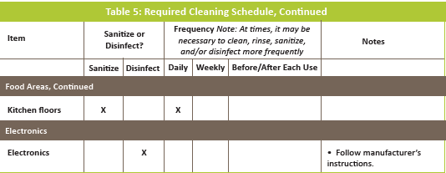

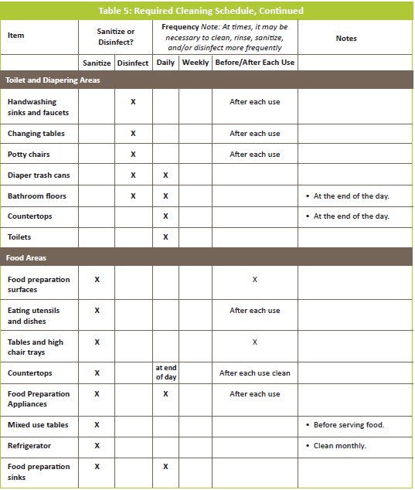

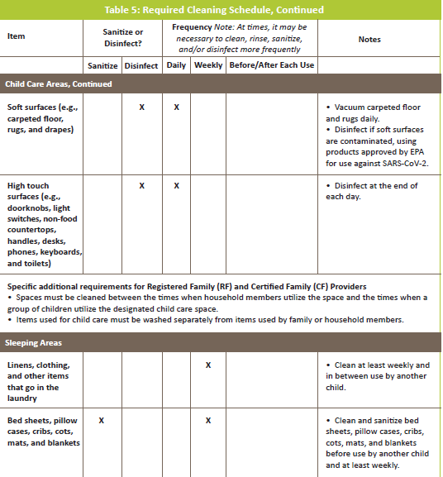

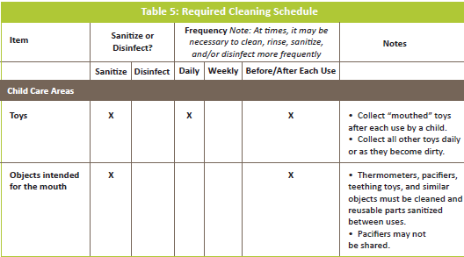

appendix c

Appendix d

